





**Group 1 Grain Elevator**

**Quick Guide Instructions for**

**Iowa EASY Air**

Iowa Department of Natural Resources

Wallace State Office Building

Air Quality Bureau

502 E 9th St

Des Moines, IA 50319

Phone: (515) 725-8200

**Contact the Iowa EASY Air Helpdesk**

**Email:** [**easyair@dnr.iowa.gov**](mailto:easyair@dnr.iowa.gov)

**Or call (515) 725-9569 or** **(515) 204-3749**

# Table of Contents

Table of Contents 2

List of Figures 2

1. Adding the Group 1 Grain Elevator Application to Your Account 3

2. Finding the Group 1 Grain Elevator Application 6

3. Filling Out and Submitting a Group 1 Grain Elevator Application 7

3.1 Introduction 8

3.2 Permitting Requirements for Group 1 Grain Elevators 8

3.3 Contact Information 8

3.3.1 Facility Contact Information 8

3.3.2 Facility Information 9

3.4 Attachments 9

3.5 Validation 11

3.6 Payment 11

3.7 Submission 12

# List of Figures

Figure 1 Dashboard Buttons to Create a New Submittal 3

Figure 2 Submittal Menu 3

Figure 3 Link to Submittal Types Associated with my Account 4

Figure 4 Available Submittal Types 4

Figure 5 My Account Menu 5

Figure 6 Basic Information Tabs 5

Figure 7 Associate Facility Button 5

Figure 8 Associate Facility Search 6

Figure 9 Facility Search Results and Adding Submission Type 6

Figure 10 Dashboard Buttons to Create a New Submittal 7

Figure 11 Submittal Menu 7

Figure 12 Construction – Group 1 Grain Elevator Icon 7

Figure 13 Permitting Requirements for Group 1 Grain Elevators Statement 8

Figure 14 Facility Contact Information 8

Figure 15 Facility Information 9

Figure 16 Attachment Screen 10

Figure 17 Attachment Screen 10

Figure 18 Example Attachment Screen 10

Figure 19 Example Validation Screen 11

Figure 20 Example Payment Screen 12

Figure 21 Example Certificate of Submission Screen 12

Figure 22 Confirmation of Submittal 13

This document provides directions on how to apply for a registration for a Group 1 Grain Elevator in the Iowa EASY Air System.

(Note: This document is written to explain how a Responsible Official can submit a registration for a Group 1 Grain Elevator. As with other submittal types within the Iowa EASY Air system, the Responsible Official may delegate the completion of these forms to a Preparer. The Preparer can complete the forms and have the Responsible Official complete the certification and submit the registration application. The instructions for assigning a Preparer for a facility and submittal type are covered in other parts of the Iowa EASY Air documentation.)

# Adding the Group 1 Grain Elevator Application to Your Account

Before you are able to apply for a registration for a Group 1 Grain Elevator in the Iowa EASY Air system, you will need to add the Group 1 Grain Elevator application to your account.

**Viewing Associated Application Types**

If you do not know what application types are associated to your account, you may navigate to the Air Department Submittal Type List page and view the submittal types associated with your account. There are two ways to the Air Department Submittal Type List page within the Iowa EASY Air system.

For one method, on your dashboard click on the “Apply for a New Submittal” button in the upper left-hand corner of the dashboard as shown in Figure 1.

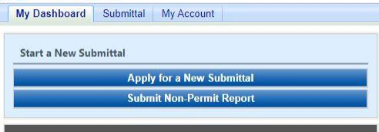

Figure 1 Dashboard Buttons to Create a New Submittal

Alternatively, hover over the Submittal dropdown menu and select “Start a New Submittal” as shown in Figure 2.

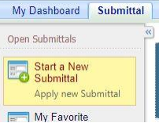

Figure 2 Submittal Menu

Next, you will see the application icons for the different types of submittals available to you in the system as shown in Figure 3.

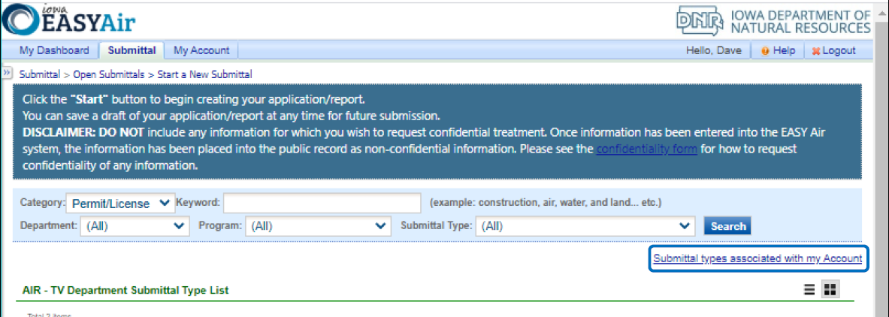

Figure 3 Link to Submittal Types Associated with my Account

Next, click on the link labeled “Submittal types associated with my Account” on the right side of the screen and the “Available Submittal Types” screen will appear as shown in Figure 4. On this screen, you are able to view the available submittal types and the submittal types already associated with your account.

A screenshot of the "Available Submittal Types". Two sections are shown, the "Available Submittal Types" and "Submittal Type Association Instruction".

Figure 4 Available Submittal Types

If you don’t see the Group 1 Grain Elevator application associated with your account, click on “Add More”. This will take you to the “Basic Information” page. Follow the instructions below to associate the application type.

**Associate an Application Type**

To associate an application type to your account, you will need to navigate to the “Associate Facilities” tab. To navigate to the “Associate Facilities” tab, on your dashboard hover on “My Account” and click on “Basic Information” as shown in Figure 5.

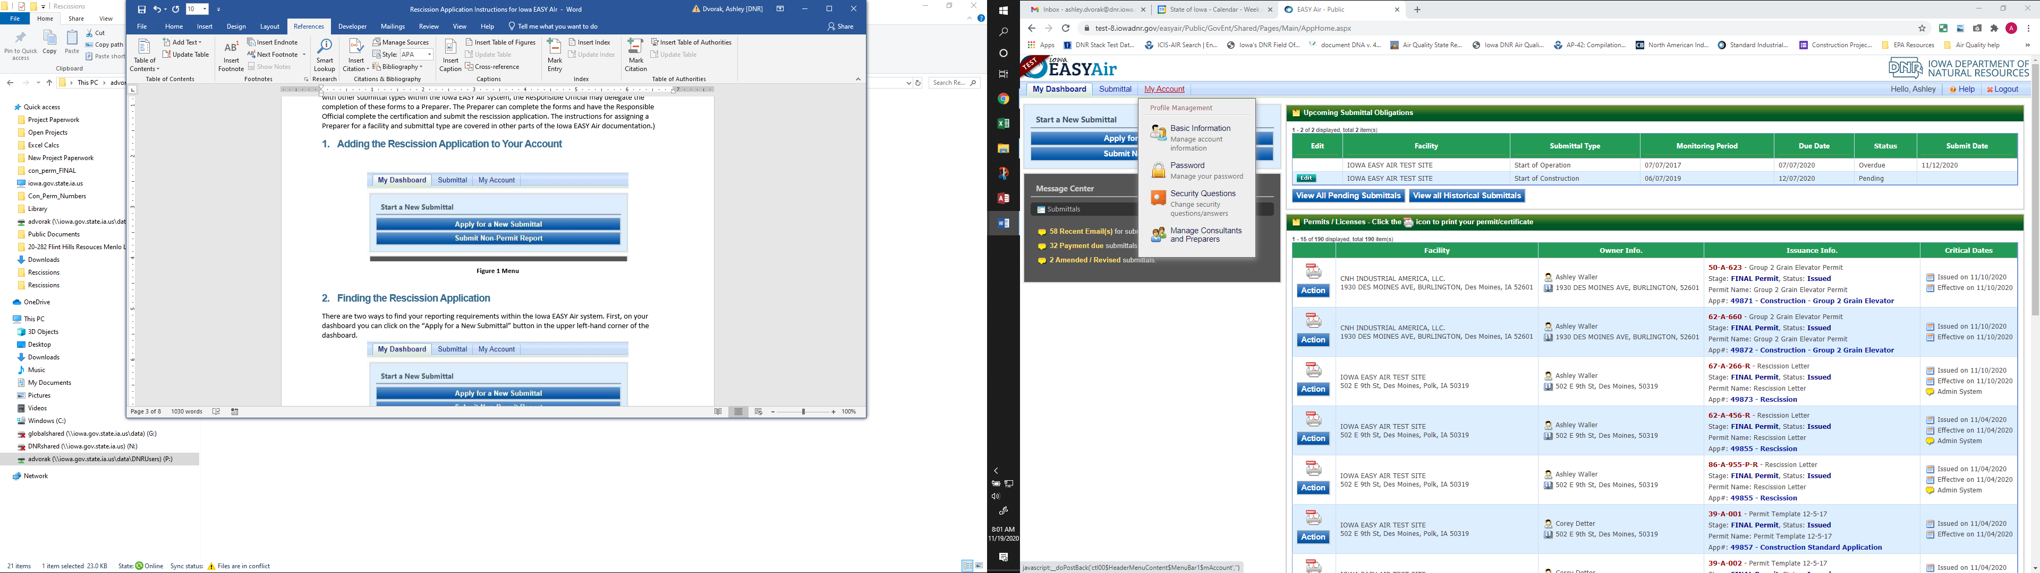

Figure 5 My Account Menu

The Basic Information page will appear. As shown in Figure 6, this page will have four tabs on top. Click on the “Associate Facilities” tab. This tab will show all your associated facilities and application types you currently have on your account.

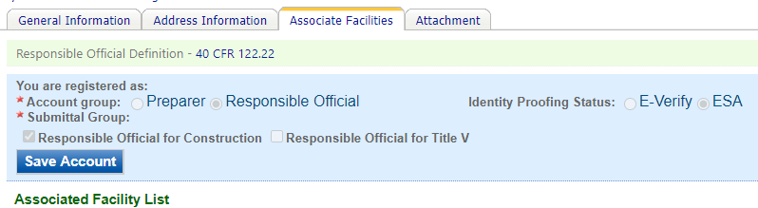

Figure 6 Basic Information Tabs

Next, scroll to the bottom of the page and you should see three buttons, as shown in Figure 7 below. Please click on “Associate Facility”.

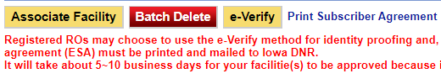

Figure 7 Associate Facility Button

The facility search will appear as shown in Figure 8 below. Enter in your facility information and click, “Search”. You may search by Facility Name, Address, or Facility Number.

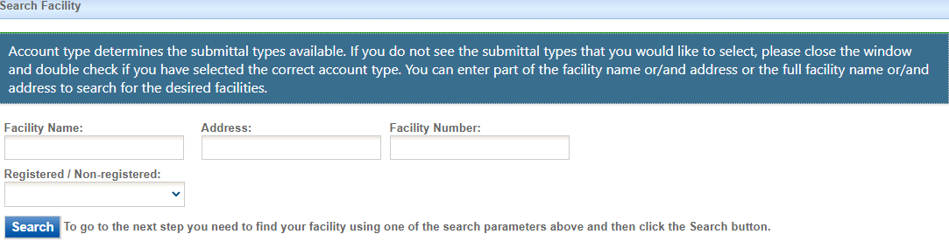

Figure 8 Associate Facility Search

The facility information will appear below the facility search as shown in Figure 9. Select the check box for the facility and the “Construction – Group 1 Grain Elevator” check box under submission type.

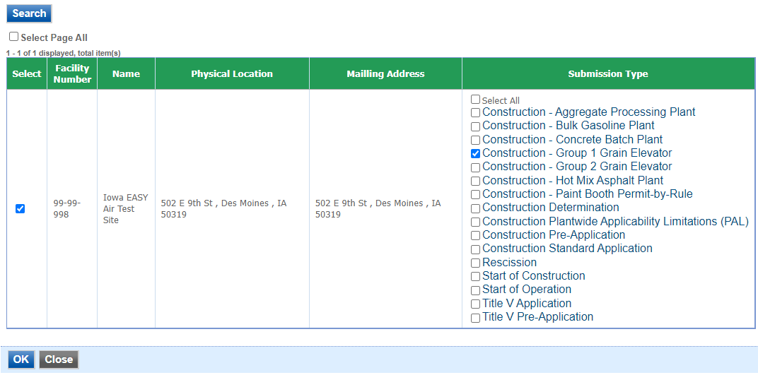

Figure 9 Facility Search Results and Adding Submission Type

Next, click “Ok” and then click “Close”. This will associate the Group 1 Grain Elevator application to your account. If you went through the e-Verify subscriber agreement process when you set up your account, you will be able to use the Group 1 Grain Elevator application after this step. However, if you sent in the paper subscriber agreement form, you will have to wait until the Iowa EASY Air Administrator completes the association of the Group 1 Grain Elevator application to your account. You will receive an email from the Iowa EASY Air Administrator when the association of the Group 1 Grain Elevator application has been made to your account.

# Finding the Group 1 Grain Elevator Application

There are two ways to start an application within the Iowa EASY Air system. For one method, on your dashboard you can click on the “Apply for a New Submittal” button in the upper left-hand corner of the dashboard as shown in Figure 10.



Figure 10 Dashboard Buttons to Create a New Submittal

Alternatively, hover over the “Submittal” tab and select “Start a New Submittal” as shown in Figure 11.



Figure 11 Submittal Menu

Next, you will see the application icons for the different types of submittals available to you in the system. The Construction – Group 1 Grain Elevator icon is shown below in Figure 12. Please select “Start” at the bottom right hand corner of the icon to start the Group 1 Grain Elevator application.

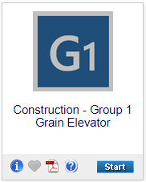

Figure 12 Construction – Group 1 Grain Elevator Icon

# Filling Out and Submitting a Group 1 Grain Elevator Application

In order to apply for a registration for a Group 1 Grain Elevator, you must first verify that the proposed facility meets the Potential-to-Emit (PTE) limitations contained in the registration. Only grain elevators with a potential to emit of less than 15 tons PM10 emissions per year are eligible to use Group 1 Registration. Grain elevators with a potential to emit of between 15 and 50 tons PM10 emissions per year should apply for a Group 2 permit. Potential PM10 Emissions Calculations may be calculated using the [GrainPTE Calculation Tool](https://iwrc.org/grain_pte). If you have questions about how to use the GrainPTE Calculation Tool, please contact the Iowa Waste Reduction Center at 1-800-422-3109.

The Iowa EASY Air application has been designed to walk you through each part of the registration to verify that the proposed facility will meet the limitations established in the registration document. The registration will not be valid until reviewed and issued by the Department.

No changes may be made to any of the conditions. If you cannot meet those conditions or want to operate differently, you should complete a Construction Standard Application for each emission unit at the facility.

## Introduction

Next, the Introduction screen will appear. The Introduction screen has links to the Department’s list of [Group 1 Grain Elevator Registrations](https://www.iowadnr.gov/portals/idnr/uploads/air/insidednr/conpermit/group1_reg.pdf), to verify if the facility has already submitted a registration. This screen also contains a link to the [GrainPTE Calculation Tool](https://www.iwrc.org/grain_pte) to calculate emissions from the facility. If you have questions about how to use the GrainPTE Calculation Tool, please contact the Iowa Waste Reduction Center at 1-800-422-3109. Once you have verified that this facility does not already possess a registration and have completed calculating the PTE from the facility using the GrainPTE Calculation Tool, please click on “Save” and then “Next”.

## Permitting Requirements for Group 1 Grain Elevators

Next, the Permitting Requirements for Group 1 Grain Elevators screen will appear (see Figure 13). Please read the Permitting Requirements for Group 1 Grain Elevators section carefully to be certain you can meet the conditions contained therein. Once you have reviewed the conditions and have determined that the template is applicable to your facility, please check the box at the bottom that you have read the section, then click on “Save” and then “Next”.

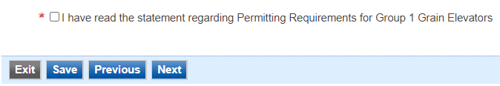

Figure 13 Permitting Requirements for Group 1 Grain Elevators Statement

## Contact Information

Next, the Contact Information screen will appear (see Figure 14 and 15).

#### Facility Contact Information

Please provide the name and contact information for the person within the company who should be contacted regarding questions or other pertinent information related to the registration application. If this person is the responsible official, please check the box stating this. All fields with a red asterisk are required to be filled in.

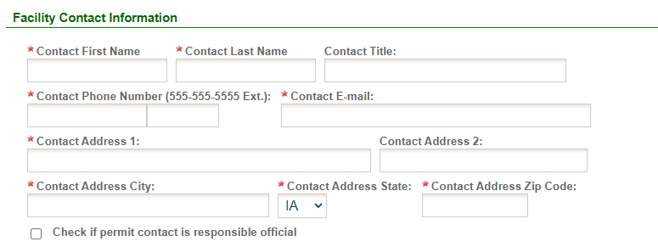

Figure 14 Facility Contact Information

#### Facility Information

Please click on the “Company/Facility Name:” dropdown box and select the Company/Facility Name that the permit should be associated to. The mailing address and facility address will auto-fill. If the facility information is not correct, please contact [easyair@dnr.iowa.gov](mailto:easyair@dnr.iowa.gov) to change the facility information.

Next, enter the equipment location. If you select “Same as Facility Address”, the information will be copied from the facility address information.

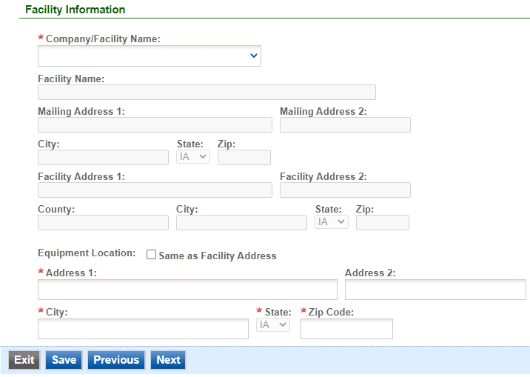

Figure 15 Facility Information

Once you have finished entering the information, click “Save” and then “Next”. If there is required information missing from the section, the Iowa EASY Air system will highlight the required fields in red. You may proceed with the application, but the system will not allow you to submit the application until all the required fields are completed during the Validation step.

## Attachments

Next, the Attachments screen will appear (see Figure 16). Potential PM10 Emissions Calculations is a required attachment for this submittal type. Potential PM10 Emissions Calculations should be printed out from the [GrainPTE Calculation Tool](https://iwrc.org/grain_pte). If you have questions about how to use the GrainPTE Calculation Tool, please contact the Iowa Waste Reduction Center at 1-800-422-3109. Attach any other information that you believe would be relevant (i.e. site plan, list of equipment, etc.) in obtaining the Group 1 registration.

Attachments may be uploaded to the application electronically, or mailed/faxed to the Department.

The Iowa DNR recommends that attachments be submitted electronically so as to not slow down the application process.

Please attach any documents required to assist the assigned engineer with completing the project on this screen.

To include your attachment(s) in the Iowa EASY Air system, select the “Online” radio button and then click on the "Upload" button. Only one file may be uploaded at a time, and the maximum file size allowed is 100 MB.

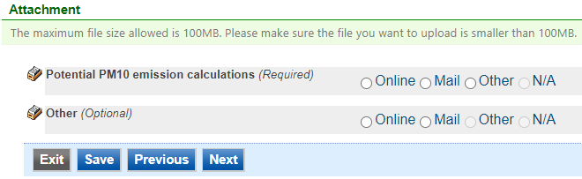

Figure 16 Attachment Screen

Select “Choose File” to select the document to be uploaded (see Figure 17). These file types are accepted by the system:

* pdf, doc, docx, txt, xls, xlsx, cvs
* jpeg, jpg, bmp, png, gif
* xml

You may include a comment for each attachment. When you have successfully selected the document, click on “Save” to upload the attachment.

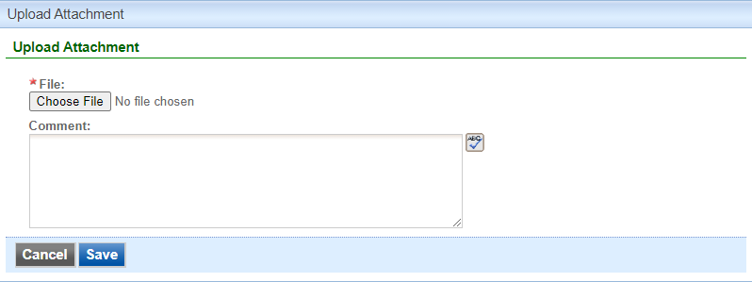

Figure 17 Attachment Screen

The uploaded attachment will display on the screen as shown in Figure 18. To remove an attachment, click the red “x” icon. The Iowa EASY Air system will confirm with you that you want to delete the record with a pop-up message. Select “Ok” on this message to confirm, or “Cancel” to stop the deletion request. To edit the attachment comment, click on the attachment comment, edit the comment, then select “Save” to update the comment or “Cancel” to cancel the change.

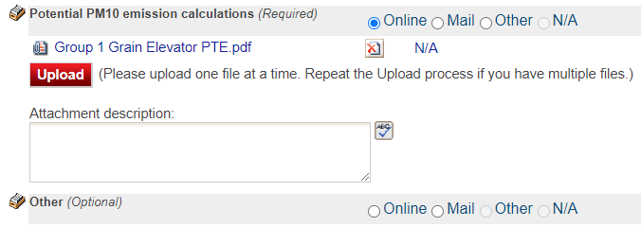

Figure 18 Example Attachment Screen

Please click “save” at the bottom of the screen to save the page.

If you do not click “save” before loading into another page, you will lose your current progress entering information.

If you plan to mail or fax the attachments, please select the “Mail” radio button on the attachment screen. If mailing attachments, include the attachment descriptions and submittal ID. Mail attachments to the following address:

Application Login Desk

Air Quality Bureau

502 E 9th Street

Des Moines, IA 50319

If faxing documents, include the attachment descriptions and submittal ID. The Air Quality Bureau fax number is (515) 725-9501.

## Validation

Next, the Validation screen will appear (see Figure 19). The system will check the application forms for required information that is missing, and will display a result similar to the figure below:

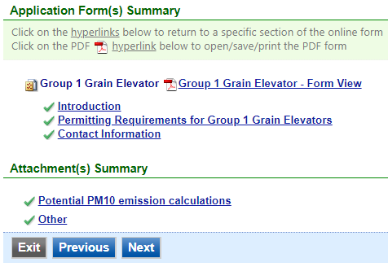

Figure 19 Example Validation Screen

If there are no noted issues, click the “Next” button. If there are issues, you may navigate to the section by selecting the section on this screen to complete the missing information.

Please note that the system will only check for missing information, and will not validate whether the information is complete or accurate.

## Payment

Next, the Payment screen will appear (see Figure 20). The application fee for Group 1 Grain Elevator registration is $100.00 per application for each plant. You may pay for the application fee by Credit Card, Check, Money Order, or eCheck (ACH – NACHA).

The Iowa DNR recommends that payment be submitted electronically (Credit Card or eCheck) so as to not slow down the application process.

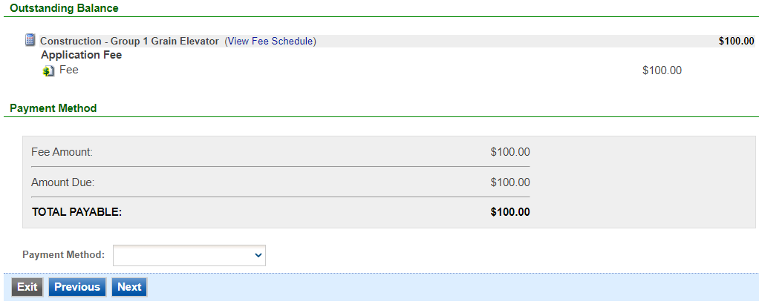

Figure 20 Example Payment Screen

If paying by Credit Card or eCheck, please use the “Online Checkout” option in the dropdown menu. The system will request the applicable information for each type of payment. If paying by Check or Money Order, select the appropriate method in the dropdown menu. When sending the payment via mail, please use the following information for payment:

* Pay To: Iowa Department of Natural Resources
* Address: Wallace State Office Building 502 E 9th St, 4th Floor, Des Moines IA 50319
* Please print a copy of the submittal receipt and mail it in with the payment or write the submittal ID number on the check or money order.

When you have finished, click the “Next” button.

## Submission

Next, the Certification of Submission screen will appear (see Figure 21). Please review the statement at the top of the screen, then check the box at the top of the screen, answer the security question, enter your pin, and click “Submit”.

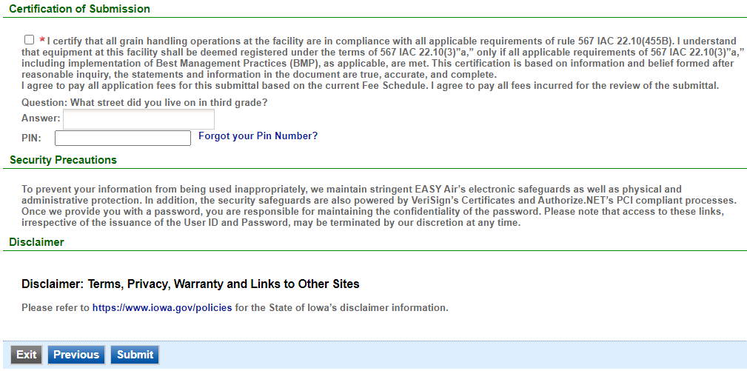

Figure 21 Example Certificate of Submission Screen

You will get a confirmation screen similar to the one shown below in Figure 22 and a confirmation email will be sent you.

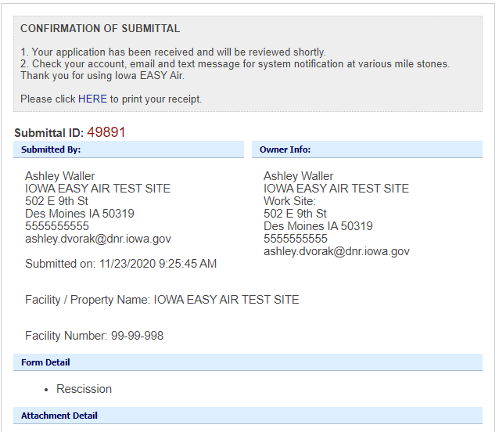

Figure 22 Confirmation of Submittal

**If you have questions, please call the Iowa EASY Air Helpdesk  
at (515) 725-9569 or (515) 204-3749.**

**Or, send an email to** [**easyair@dnr.iowa.gov**](mailto:easyair@dnr.iowa.gov)